Item Catalog Install Instructions

1. Download latest zip file
2. Create folder path `C:\Program Files\ItemCatalog`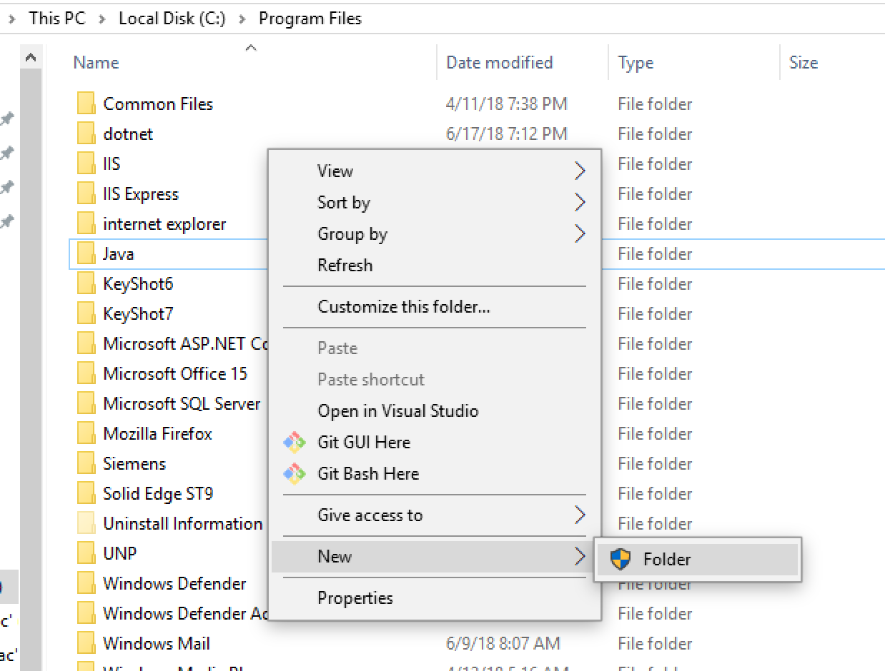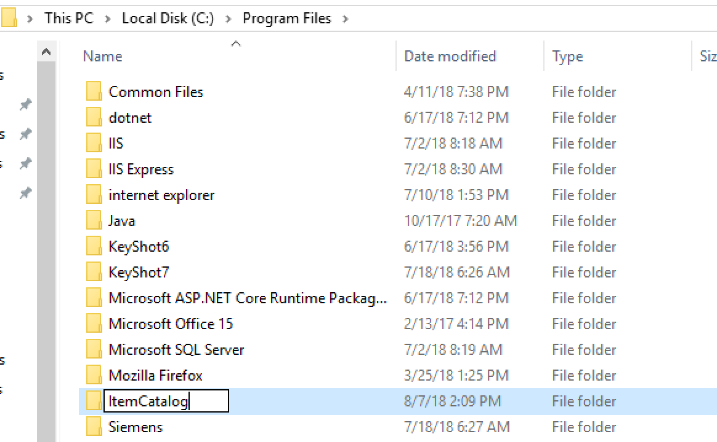
3. Unzip file to the folder path `C:\Program Files\ItemCatalog`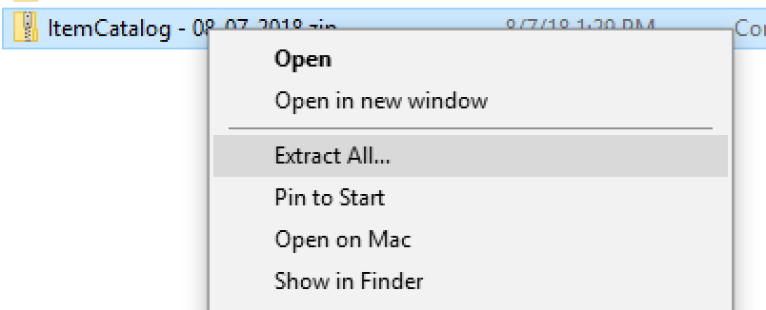

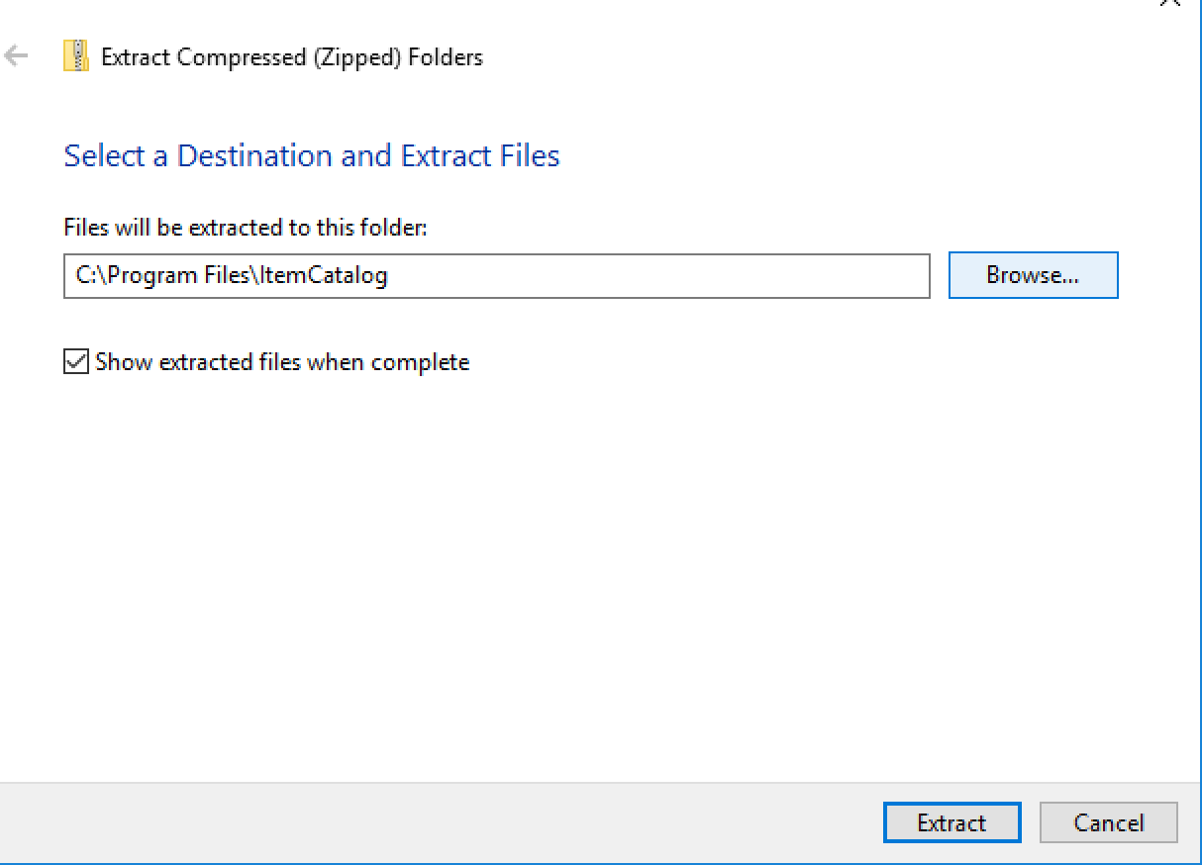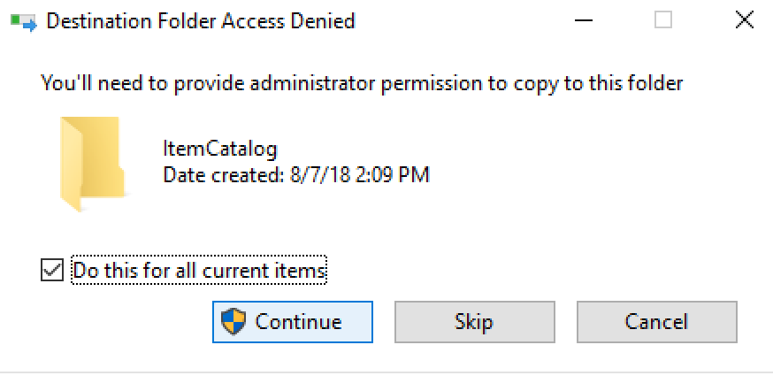

1. Run `C:\Program Files\ItemCatalog\Registration.bat` with administrator privileges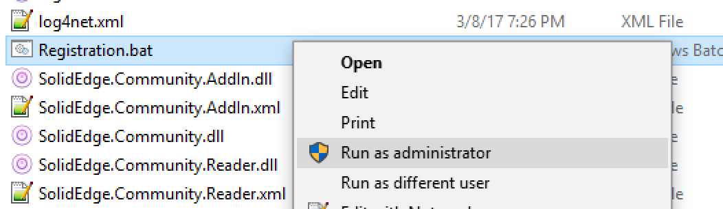

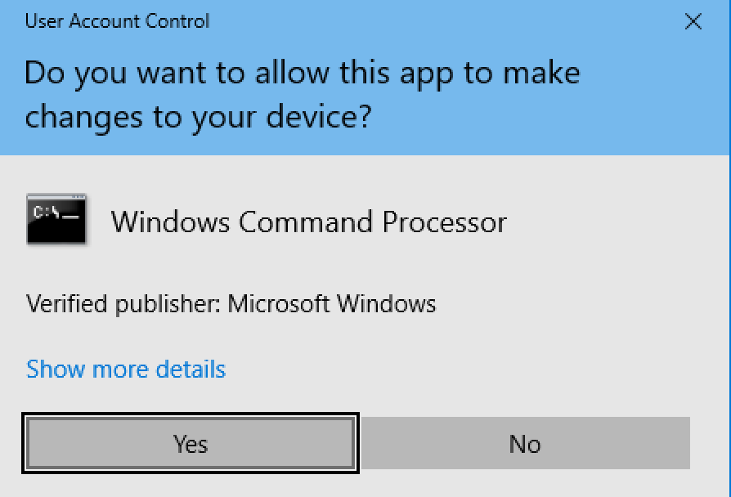

1. Enter `1` for Registration when prompted on screen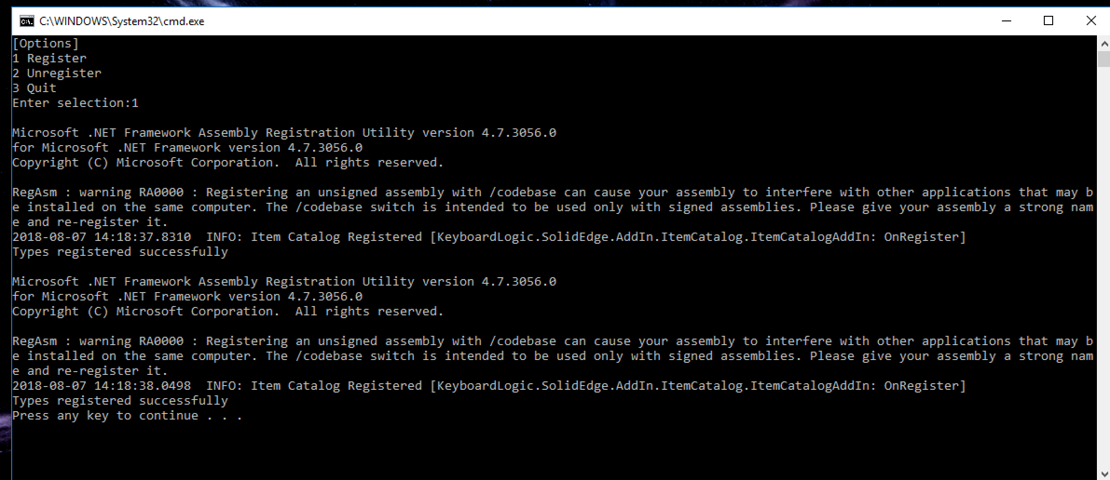
2. Hit any key to close installer